ASSIGNMENT-4.3
Task Description#1
• Zero-shot: Prompt AI to write a function that checks whether a given year is a leap
year.
Expected Output#1
• AI-generated function with no examples provided.
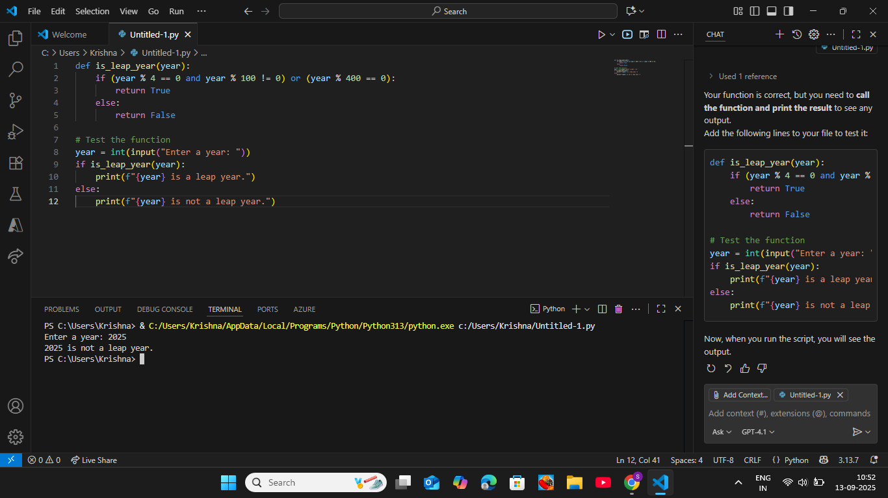

Task Description#2
• One-shot: Give one input-output example to guide AI in writing a function that
converts centimeters to inches.
Expected Output#2
• Function with correct conversion logic.

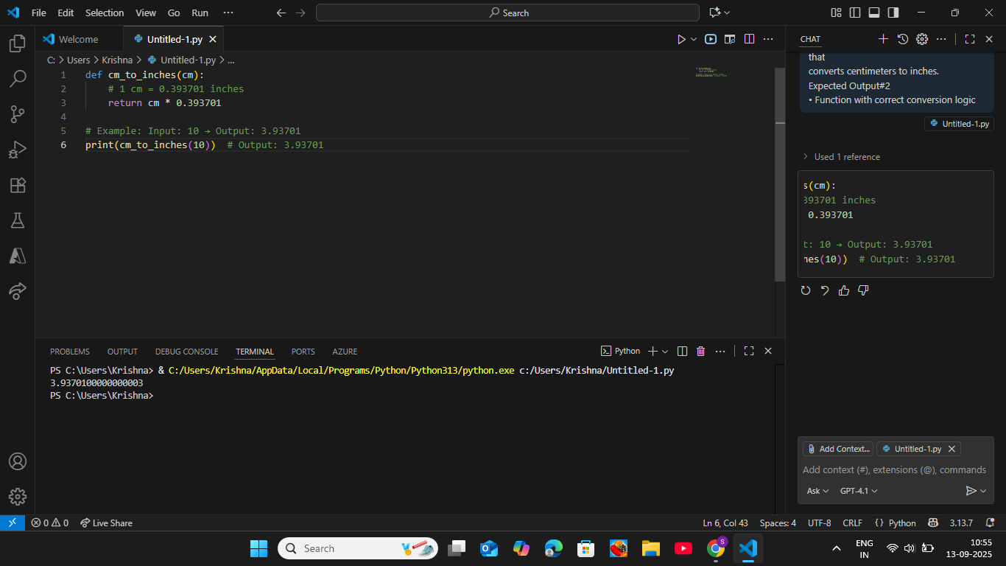

Task Description#3
• Few-shot: Provide 2–3 examples to generate a function that formats full names as
“Last, First”.
Expected Output#3
• Well-structured function respecting the examples.

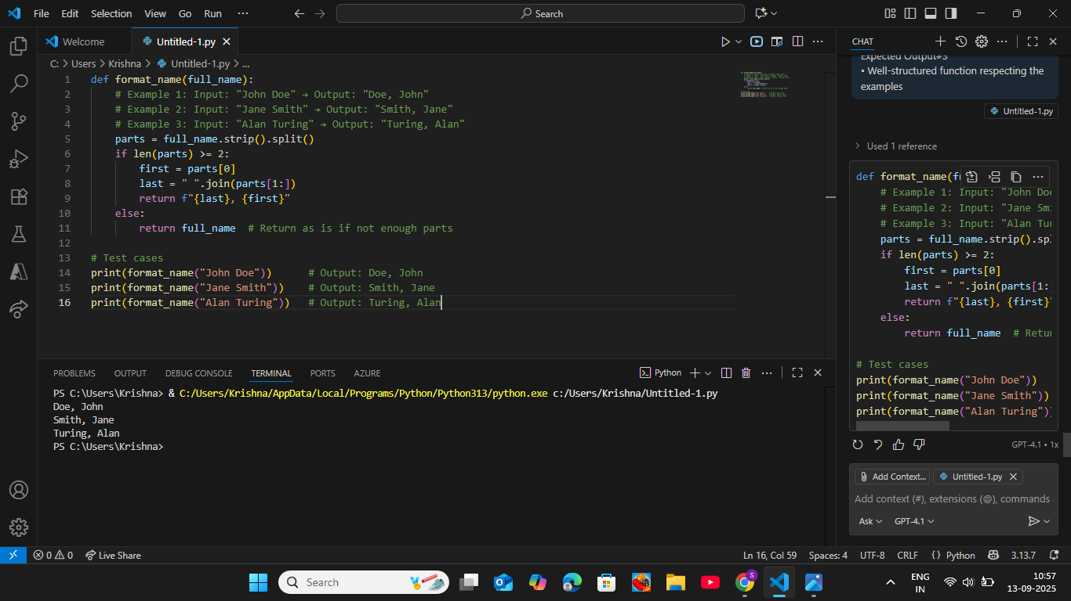

Task Description#4
• Compare zero-shot and few-shot prompts for writing a function that counts the
number of vowels in a string.
Expected Output#4
• Functional output and comparative reflection.

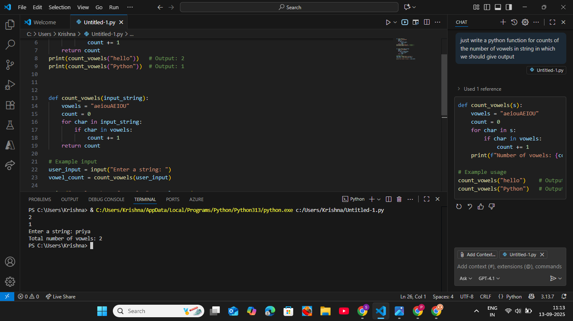

Task Description#5
• Use few-shot prompting to generate a function that reads a .txt file and returns the
number of lines.
Expected Output#5
• Working file-processing function with AI-guided logic.

